Parallel and Distributed Computing
Cloud computing provides on-demand access to shared computing resources such as servers, storage, and applications over the Internet.
It follows a pay-per-use model, where users pay only for the resources they consume.
Cloud systems rely on parallel and distributed computing technologies to achieve scalability, reliability, and efficiency.

Eras of Computing
Computing has evolved through two major eras:
- Sequential Computing Era (1940s)
  - Early computers executed instructions one after another.
  - Processing was slow because only one instruction was executed at a time.
- Parallel / Distributed Computing Era
  - Introduced to meet the growing demand for high performance and scalability.
  - Multiple processors began working together to solve problems faster.
  - Developments occurred in hardware architectures, compilers, applications, and problem-solving environments.
  - Over time these technologies became commercialized and widely used.
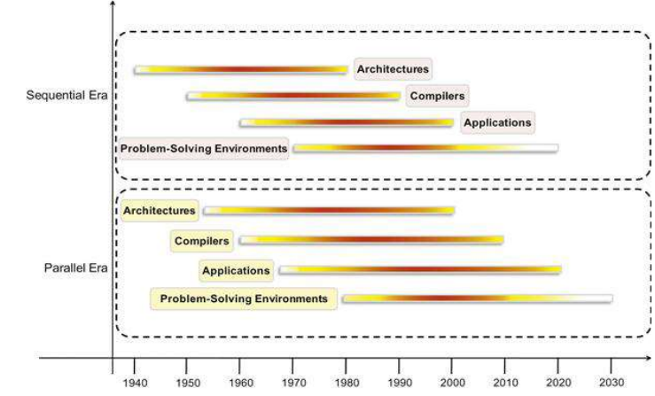

Parallel Computing
Parallel computing is a computing technique where multiple processors or cores execute multiple tasks simultaneously to solve a problem faster.
Instead of solving a problem sequentially, the problem is divided into smaller parts and executed at the same time by different processors.
Characteristics
- Uses multiple processors
- Tasks executed simultaneously
- Usually occurs within a single machine
- Uses shared memory
Example
A multi-core CPU where each core executes part of a program simultaneously.
Example operation: [1,2,3] + [4,5,6] → [5,7,9] All additions are performed simultaneously.
Factors Influencing Parallel Processing
- Increasing computational demand in scientific and business applications
- Physical limits of single processors (heat, speed, transistor density)
- Improved networking technologies
- Need for faster processing
Example: Weather prediction using many processors working together.

Distributed Computing
Distributed computing is a system where multiple independent computers (nodes) connected through a network work together to solve a problem.
According to Tanenbaum: “A distributed system is a collection of independent computers that appears to its users as a single coherent system.”
Characteristics
- Multiple independent computers
- Communication through network messages
- Systems may be geographically distributed
- Resources are shared across nodes
- Provides fault tolerance and scalability
Example
When a user accesses a website, multiple servers process the request in the background but appear as a single system to the user.
Feature | Parallel Computing | Distributed Computing
System | Usually within one machine | Multiple computers
Coupling | Tightly coupled | Loosely coupled
Communication | Shared memory | Network communication
Hardware | Homogeneous | Often heterogeneous
Example | Multi-core CPU | Cloud computing systems

Role in Cloud Computing
Parallel and distributed computing form the foundation of cloud computing systems.
They enable:
- Efficient utilization of IT resources
- Large-scale data processing
- High performance computing
- Scalability of applications
- Reliability and fault tolerance

Elements of Parallel Computing
Parallel computing is a computing technique in which multiple processors execute different parts of a problem simultaneously to improve performance and reduce execution time. To design efficient parallel systems, several important elements must be considered.
1. Decomposition
Decomposition is the process of dividing a large problem into smaller sub-problems or tasks so that they can be executed simultaneously by different processors.
Example:
In image processing, an image can be divided into several sections and each processor processes one section.

2. Task Assignment (Task Distribution)
After decomposition, the tasks must be assigned to different processors so that all processors work efficiently.
Example:
In a multi-core processor, each core is assigned a part of the program.

3. Communication
Processors often need to exchange data with each other during execution.
Communication can happen through:
- Shared memory
- Message passing
Example:
Processors working on different parts of a weather prediction model exchange intermediate results.

4. Synchronization
Synchronization ensures that processors coordinate their execution correctly.
Sometimes a processor must wait until another processor finishes its task before continuing.
Example:
In matrix multiplication, one processor may need results computed by another processor.

5. Scalability
Scalability refers to the ability of a parallel system to maintain efficiency when the number of processors increases.
A good parallel system should handle increasing workloads without losing performance.
Example:
Cloud computing systems can increase the number of processors when demand increases.

Components of a Distributed System
A distributed system consists of several layers that work together to allow multiple computers to function as a single system.

1. Hardware
Hardware represents the physical devices that form the distributed system.
Includes
- Computers
- Servers
- Network cards
- Switches
- Communication networks (LAN / Internet)
Example
Many computers connected through a LAN or the Internet.

2. Operating System
The operating system manages the hardware resources of each machine.
Functions
- Process management
- Memory management
- File management
- Device control
Example
Operating systems such as Linux or Windows running on each server.

3. IPC Primitives for Control and Data
IPC (Inter-Process Communication) enables communication between processes running on different machines.
Functions
- Message passing
- Data exchange
- Synchronization between processes
Example
One computer sends a request message, and another computer sends a reply message.

4. Middleware
Middleware is a software layer between the operating system and applications.
Functions
- Provides communication services
- Hides network complexity
- Supports distributed programming
Example
Middleware systems such as:
- RPC (Remote Procedure Call)
- Distributed object frameworks
Example: A middleware service managing remote procedure calls.

5. Applications
Applications are the end-user programs that run on top of the distributed system.
Examples
- File sharing systems
- Media streaming platforms
- Cloud applications
Example
A music streaming application that retrieves songs from multiple servers.
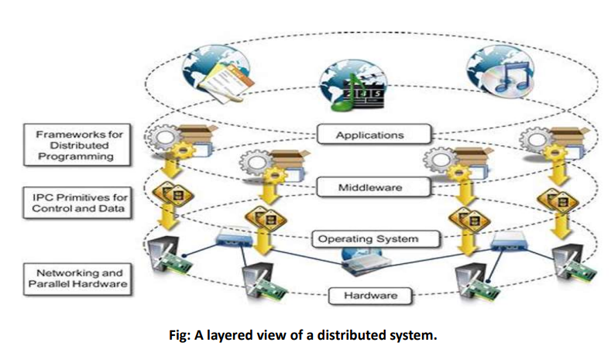

Hardware Architectures for Parallel Computing
Parallel processing systems are classified based on the number of instruction streams and data streams they handle simultaneously. This classification is known as Flynn’s Taxonomy.
The four main architectures are:
- SISD – Single Instruction Single Data
- SIMD – Single Instruction Multiple Data
- MISD – Multiple Instruction Single Data
- MIMD – Multiple Instruction Multiple Data
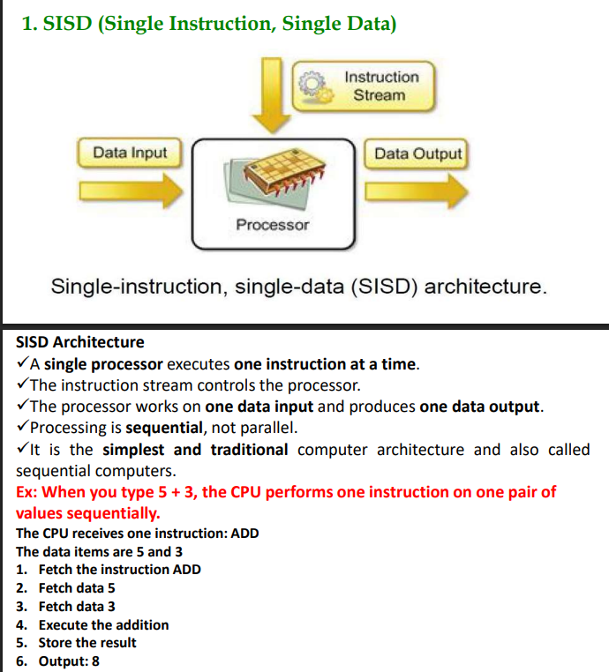

Example Systems
- Traditional computers
- Single-core processors

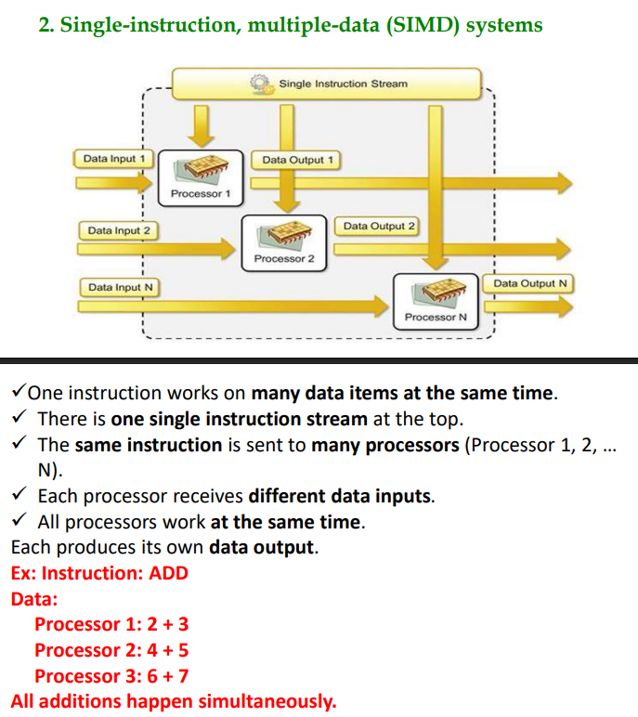

Example Systems
- Graphics Processing Units (GPUs)
- Vector processors
- Image processing systems

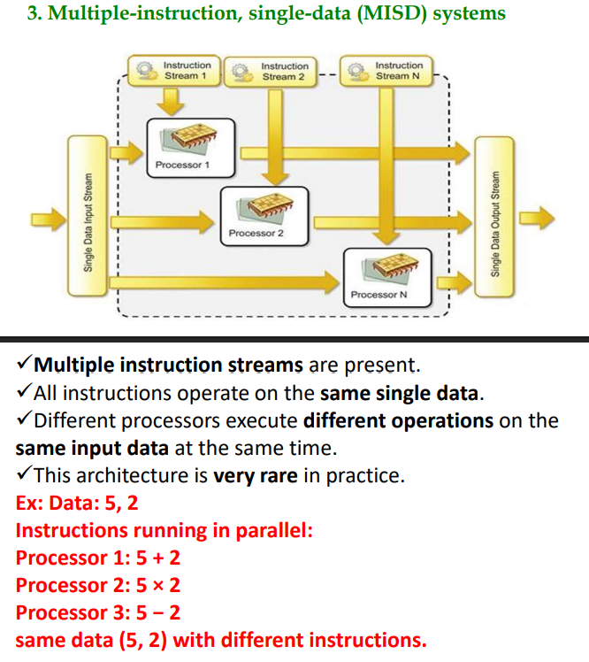

- Fault-tolerant systems
- Safety-critical systems such as spacecraft control systems.

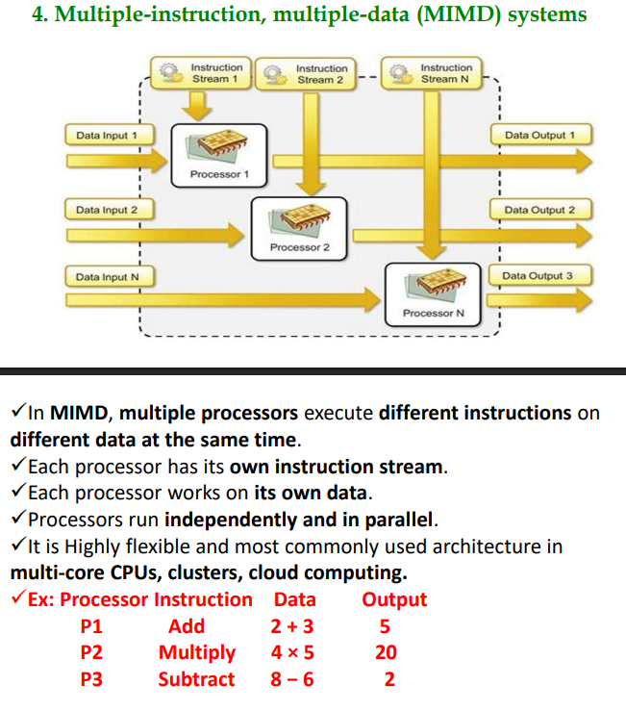

Example Systems
- Multi-core CPUs
- Cloud computing systems
- Distributed systems
- Computer clusters

Types of MIMD Architecture
1. Shared Memory Architecture
- All processors share one common memory.
- Processors communicate through shared memory.
Example: Multi-core processors.

2. Distributed Memory Architecture
- Each processor has its own local memory.
- Processors communicate using message passing or IPC.
Example: Computer clusters and distributed systems.
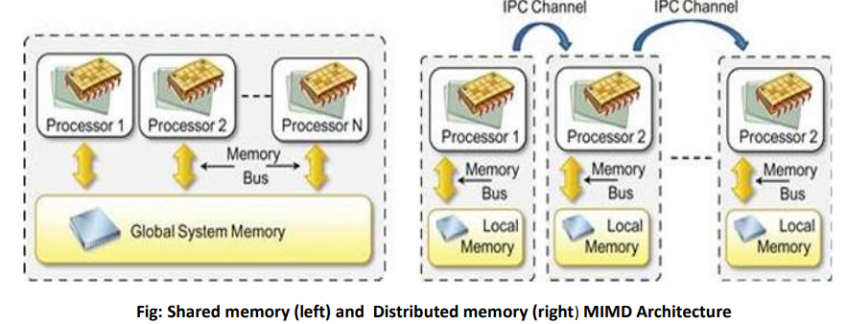

Models for Interprocess Communication (IPC)
A distributed system consists of many programs (processes) running on different computers connected through a network. These processes run simultaneously and need to communicate with each other to exchange information and coordinate their tasks. This communication is achieved using Inter-Process Communication (IPC) mechanisms.
IPC helps processes to:
- Exchange data between different machines
- Coordinate tasks and synchronize execution
- Allow all parts of a distributed system to work together as a single unified system
IPC Models
There are different models used for communication between processes in distributed systems:
1. Shared Memory
In the shared memory model, multiple processes access and communicate through a common memory space. Processes read and write data in this shared memory to exchange information.
2. Remote Procedure Call (RPC)
In the RPC model, a program can call a procedure or function located on another computer as if it were a local function call. The system handles the communication between client and server.
3. Message Passing
In the message passing model, processes communicate by sending and receiving messages over a network. This method is commonly used in distributed systems where computers do not share memory.

Remote Procedure Call (RPC)
Remote Procedure Call (RPC) is a communication mechanism that allows a program to call a procedure or function located in another process or on another computer as if it were a normal local function call. It simplifies distributed programming by hiding the details of network communication.
- RPC is a fundamental Inter-Process Communication (IPC) mechanism.
- It was first introduced in 1976 and formalized in the 1980s, and it is still widely used in modern distributed systems.
- RPC follows the client–server architecture, where the client sends a request and the server processes the request and returns the result.
  - In RPC, the program that requests the service is called the client,
  - program that executes the procedure is called the server
  - The client and server may run on the same system or on different systems connected through a network.

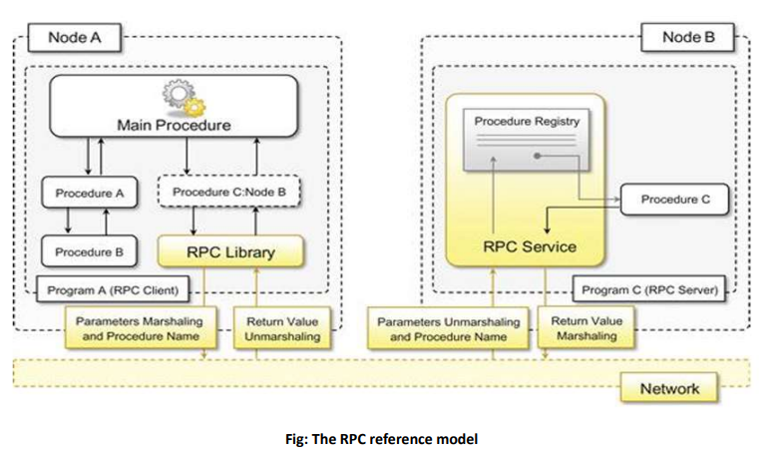
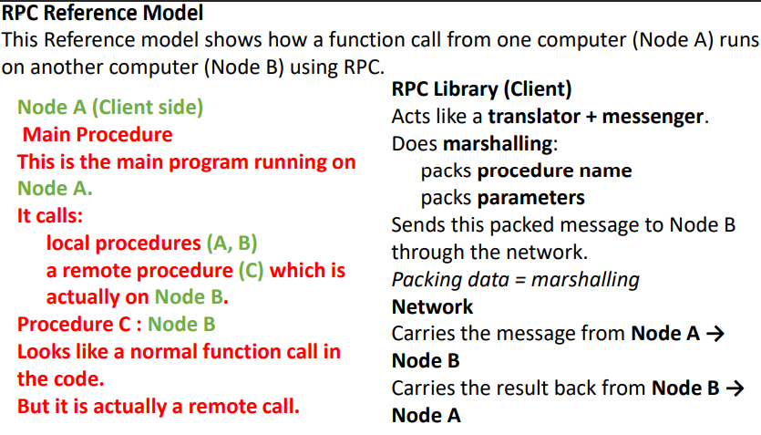
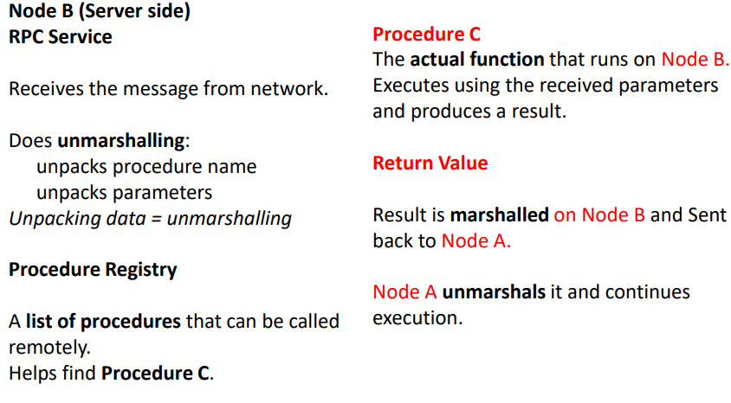
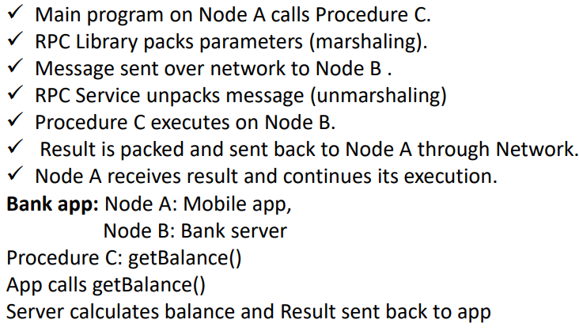

2. Distributed Object Frameworks
Distributed object frameworks provide programming models and tools that help developers build distributed applications easily. These frameworks allow objects located on different computers to communicate and interact over a network as if they were local objects.
In distributed object systems, an application can invoke methods on objects located on remote machines. The framework manages communication, object location, and execution, hiding the complexity of network programming from developers.
Distributed object frameworks typically include components such as object proxies, object skeletons, remote reference modules, and network communication mechanisms to enable interaction between distributed objects.
Example:
Frameworks such as Hadoop or Spark automatically divide data and execute tasks across multiple machines in a distributed system.

2.1 Object Activation and Lifetime
Object Activation
Object activation is the process of creating and initializing a distributed object when it is requested by a client application.
When a client tries to access a remote object:
- The system locates the object.
- If the object is not already running, it is activated or created.
- The object becomes available to handle the client request.
Example:
If a client requests a remote service object that is not currently active, the framework automatically creates the object and starts it before executing the method.

Object Lifetime
Object lifetime refers to how long a distributed object exists in the system.
The framework manages:
- Creation of objects
- Execution of methods
- Destruction of objects when they are no longer needed
Object lifetime can be managed in different ways, such as:
- Persistent objects – remain active for a long time
- Temporary objects – created for a request and destroyed after completion
Example:
A remote object created to process a user request may be destroyed after the request is completed.
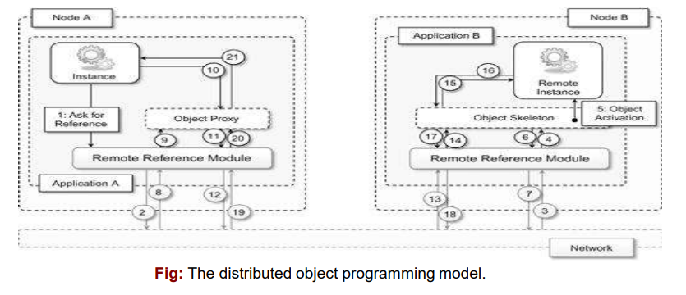

2.2 Examples of Distributed Object Frameworks
Some common distributed object frameworks include:
CORBA (Common Object Request Broker Architecture)
A standard framework that allows objects written in different programming languages to communicate across a network.
DCOM (Distributed Component Object Model)
Developed by Microsoft to enable communication between distributed components in Windows environments.
Java RMI (Remote Method Invocation)
A Java-based framework that allows Java objects to invoke methods on objects running on remote machines.

Service-Oriented Architecture (SOA)
Service-Oriented Architecture (SOA) is an architectural style in which software systems are designed as a collection of independent services that communicate with each other over a network.
A service is a small software component that performs a specific business function. These services can interact with each other even if they belong to different systems or organizations.
SOA enables applications to be flexible, reusable, and loosely coupled, making it suitable for distributed and cloud-based systems.
Example
An online shopping system may use different services such as:
- Payment service
- Shipping service
- Notification service
Each service performs a specific task but works together to complete the overall process.

Roles in SOA
There are two major roles in Service-Oriented Architecture:
1. Service Provider
The service provider is responsible for creating, maintaining, and offering the service.
Functions:
- Develops the service
- Publishes service information in a registry
- Provides a service contract describing how the service can be used
Example:
A company providing online payment services such as PhonePe or credit card payment services.

2. Service Consumer
The service consumer is the user or application that uses the service.
Functions:
- Searches the service in a registry
- Accesses the service using the provided interface
- Uses the service to perform a specific task
Example:
A customer using the payment service while placing an order online.
Example workflow:
Order Processing → Payment
Order Processing → Inventory Update

Service Choreography
Service choreography is used when multiple services interact with each other independently without a central controller.
Each service listens for events and reacts accordingly.
Example:
In a distributed business system, payment, inventory, and shipping services interact automatically when an order is placed.

Guiding Principles of SOA
1. Standardized Service Contract
Services follow a standard communication agreement.
Example:
All services use the same API format.

2. Loose Coupling
Services are independent, and changes in one service do not affect others.
Example:
Changing the payment service will not affect the order service.

3. Abstraction
A service hides its internal implementation details.
Users only see what the service does, not how it works.
Example:
Users know they are making a payment but not how it is processed.

4. Reusability
A single service can be reused by multiple applications.
Example:
A payment service used by several e-commerce platforms.

5. Autonomy
Each service controls its own logic and functionality.
Service consumers do not know the internal implementation.

6. Lack of State (Statelessness)
Services do not store previous client requests.
Each request is processed independently.
Example:
An ATM asks for a PIN every time a transaction is performed.

7. Discoverability
Services can be easily discovered using metadata or service registries.
Example:
Searching a registry to find a shipping service.

8. Composability
Services can be combined to create more complex applications.
Example:
A travel booking system combining flight, hotel, and payment services.

SOA Supporting Resources
Some important resources supporting SOA include:
- SOA Manifesto – Defines principles and values of SOA.
- SOMF (Service-Oriented Modeling Framework) – Provides a modeling approach for designing SOA systems.
- OASIS (Organization for the Advancement of Structured Information Standards) – Provides standards and reference architectures for SOA.

SOA Implementation Technologies
Early SOA Technologies
- CORBA
- DCOM
Modern SOA Technologies
- Web Services
- SOAP
- REST APIs
Example:
Modern cloud and enterprise applications use REST APIs to provide services.

